How to re-enable button “Log On” of Time Registration System?

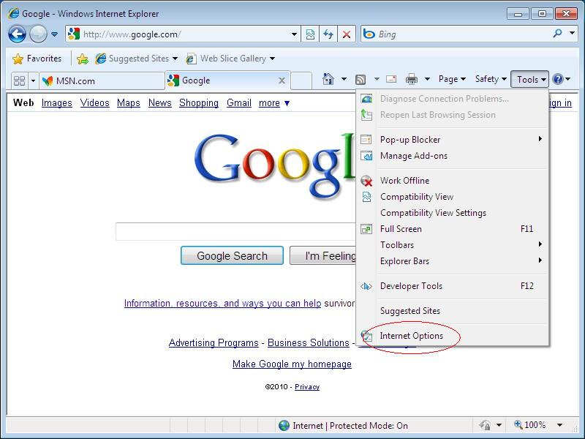
Step 1: Click button “Tools” “Internet Options”
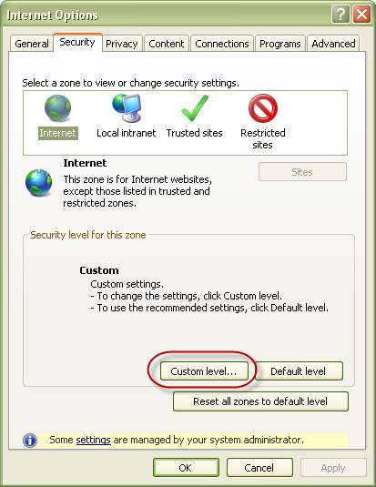
Step 2: In dialog box “Internet Options”, select tab “Security” Click button “Custom level…”
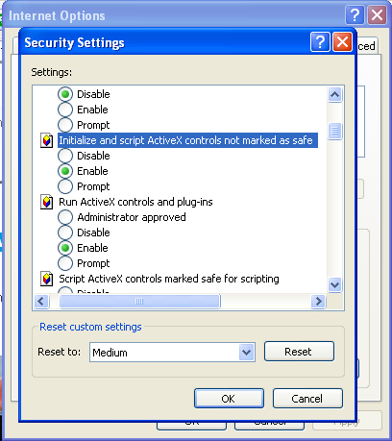
Step 3: In dialog box “Security Settings”, find the option “Initialize and script ActiveX controls not marked as safe” select “Enable” Click “OK” Click “OK” again to close dialog box “Internet Options”
Step 4: Close and restart IE browser.
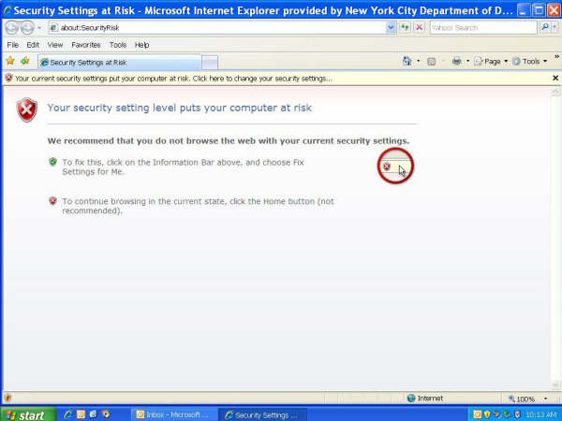
From now, when starting IE browser will display a message like the picture above, DO NOT follow its instruction to fix the security setting level.
Step 5: Click button “Home” (shown as a house) to navigate to homepage, or access TRS via address: http://airporttrs.epinion.dk/?Project=Hamburg

